Interconnected Dynamics: Analyzing Population, Climate, Healthcare and Urban Mobility in the United States

Santhosh Kumar Suresh Kumar  
santhoshkumarsures@lewisu.edu  
DATA-53000, Fall 2024

Data Visualization Lewis University

# Introduction

In this Tableau project, we aim to provide a comprehensive analysis of various datasets that illustrate key aspects of demographic and environmental data across the United States. By leveraging multiple datasets, we offer insights into population distribution, climate variations, healthcare infrastructure, and urban traffic patterns.The “USA Statewise Population 2020” dataset [1] serves as a foundational resource for understanding population density across different states, allowing for comparisons that reveal significant demographic trends. Additionally, the “Climate Change: Earth Surface Temperature Data” [2] provides valuable insights into average temperatures throughout the country, highlighting the geographical influences on climate. Healthcare distribution is examined using the “USA Hospitals” dataset [3] which maps hospital locations and ownership types, revealing the accessibility of healthcare services in various regions. Furthermore, the “Chicago Average Daily Traffic Counts” dataset [4] sheds light on traffic congestion. Together, these datasets facilitate a deeper understanding of the interplay between population, climate, healthcare, and urban dynamics in the U.S.A.

# Data Description

This project utilizes four distinct datasets that provide valuable insights into various aspects of the United States, including population demographics, climate variations, healthcare infrastructure, and urban traffic patterns. The USA Statewise Population 2020 [1] contains total population figures for each state as recorded in 2020, enabling comparisons of population density and highlighting demographic trends across the country. The Climate Change: Earth Surface Temperature Data [2] offers historical and recent temperature data, including average surface temperatures, which allows for an analysis of climate patterns and their geographical influences, as well as trends related to climate change. The USA Hospitals [3] dataset maps the locations of hospitals across the U.S., providing information on ownership types—public, private, and non-profit—which serves as a resource for understanding healthcare accessibility and distribution within different communities. Lastly, the Chicago Average Daily Traffic Counts [4] dataset illustrates traffic congestion patterns throughout Chicago, offering insights into urban mobility and the challenges faced by the city’s transportation infrastructure. Together, these datasets provide a multifaceted view of demographic and environmental factors in the U.S., facilitating a deeper understanding of the interplay between population, climate, healthcare, and urban dynamics. Table I. below identifies the 18 attributes and the 1 target variable, overall passenger satisfaction.

1. Data Attributes

| **Attribute** | **Type** | **Example Value** | **Description** |
| --- | --- | --- | --- |
| Date | Categorical | 01/01/2023 | Date of the data collection or the date the event occurred |
| Year | Categorical | 2022 | The year in which the data was collected |
| State | Categorical | California | The state or region where the data was collected |
| Total Population | Numeric | 39,538,223 | The total population of the state as recorded in the census. |
| Area | Numeric | 160,452.34 | The total land area of the state in square miles. |
| Average Surface Temperature | Numeric | 21.5 | The average temperature recorded for the specified date. |
| Latitude | Numeric | 50.3452 | The latitude coordinate of the location. |
| Longitude | Numeric | -24.4532 | The longitude coordinate of the location. |
| Location | Categorical | Los Angeles, CA | The specific geographic location (city and state). |
| Hospital Name | Categorical | General Hospital | The name of hospital. |
| Ownership Type | Categorical | Private | The type of ownership (e.g., public, private, non-profit). |
| Number of Beds | Numeric | 250 | The total number of beds. |
| Traffic Volume | Numeric | 1200 | The number of vehicles counted during the specified time. |
| Zip Code | Numeric | 60504 | The ZIP code for the hospital or traffic location. |
| Road Type | Categorical | Highway | The type of Road. |
| Time | Categorical | 08:00 AM | The time period of the traffic count (if applicable). |
| Hospital ID | Numeric | 123432 | A unique identifier for the hospital. |
| Vehicle Type | Categorical | Car | The type of vechile. |

# Methodology and results

This project employs a structured methodology to analyze four distinct datasets, providing insights into various aspects of the United States. The datasets include the USA Statewise Population 2020, which offers demographic data for population density comparisons; the Climate Change: Earth Surface Temperature Data, which supplies historical and recent temperature records for climate pattern evaluation; the USA Hospitals dataset, mapping healthcare infrastructure and ownership types; and the Chicago Average Daily Traffic Counts, which illustrates urban traffic patterns. Initially, data collection is followed by a thorough cleaning process to address missing values and inconsistencies, ensuring data integrity. Exploratory Data Analysis (EDA) is then conducted to identify trends and correlations, utilizing visualizations for clarity.

In Fig.1, This map visually represents the total population of each state in the United States. The size of each circle corresponds to the population of each state, making it easy to compare population density at a glance. California stands out as the most populous state, represented by a large circle, while Wyoming is depicted by a small circle, indicating a lower population. The map uses a color scheme that differentiates between states based on their location, with a blue hue for most of the US. This visualization provides a quick and insightful overview of population distribution across the country.

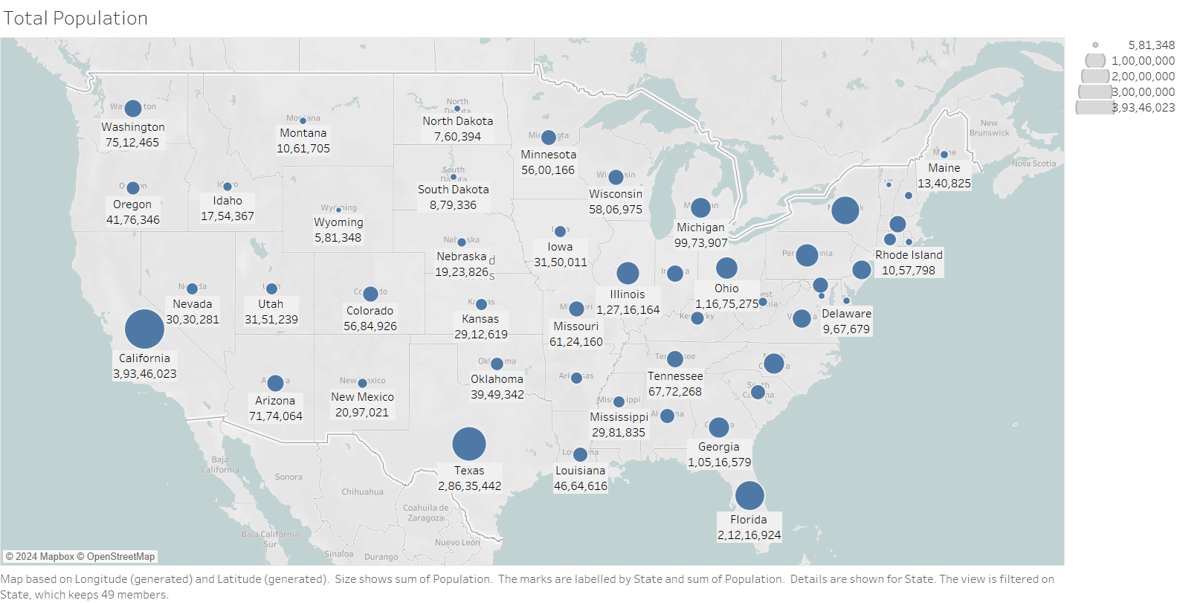

Fig. 1 Total Population of States in USA

In Fig. 2, The map visualizes the average temperatures across the United States. The color gradient ranges from blue (representing colder temperatures) to orange (representing warmer temperatures). The states in the northern and western regions of the country are predominantly blue, indicating a cooler climate. Conversely, the states in the south-central and southeastern regions are colored in shades of orange, signifying warmer temperatures. This map provides a clear overview of the temperature differences across the US, highlighting the influence of geographical location on climate.

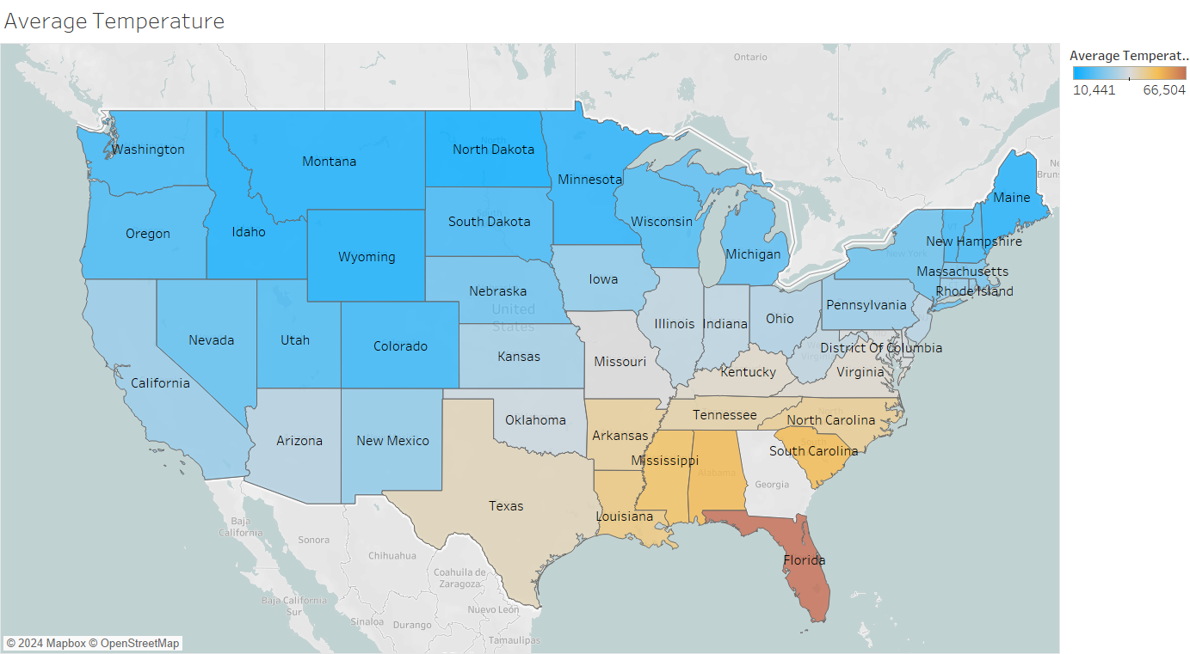

Fig. 2 Average Temperature

In Fig. 3, The map displays the locations of hospitals in and around Chicago. The map is color-coded to show the ownership type of each hospital. The colors used include blue for hospitals owned by a district or authority, orange for federal government-owned hospitals, red for locally owned hospitals, green for state government-owned hospitals, cyan for non-profit hospitals, yellow for hospitals where ownership information is not available, and purple for proprietary hospitals. The map shows that the majority of hospitals in the area are non-profit, followed by hospitals owned by a district or authority. The map is a useful tool for understanding the distribution of hospital ownership types in the Chicago area.

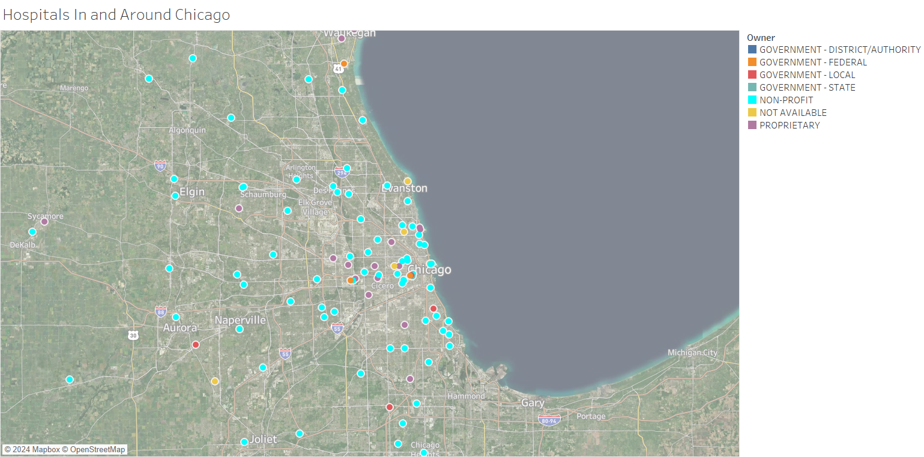

Fig. 3 Hospitals In and Around Chicago

In Fig. 4, The image shows a heat map of average monthly traffic in Chicago, with different colors representing different levels of traffic volume. The map highlights the busiest areas of the city, including the downtown loop, River North, and the Magnificent Mile. The map also shows the location of key landmarks and transportation hubs in the city, such as the Field Museum of Natural History, Millennium Park, and the Chicago River. The heat map provides a visual representation of the city's traffic patterns, revealing the areas with the highest concentration of vehicular traffic. The image is informative and visually appealing, showcasing the bustling nature of Chicago's urban landscape.

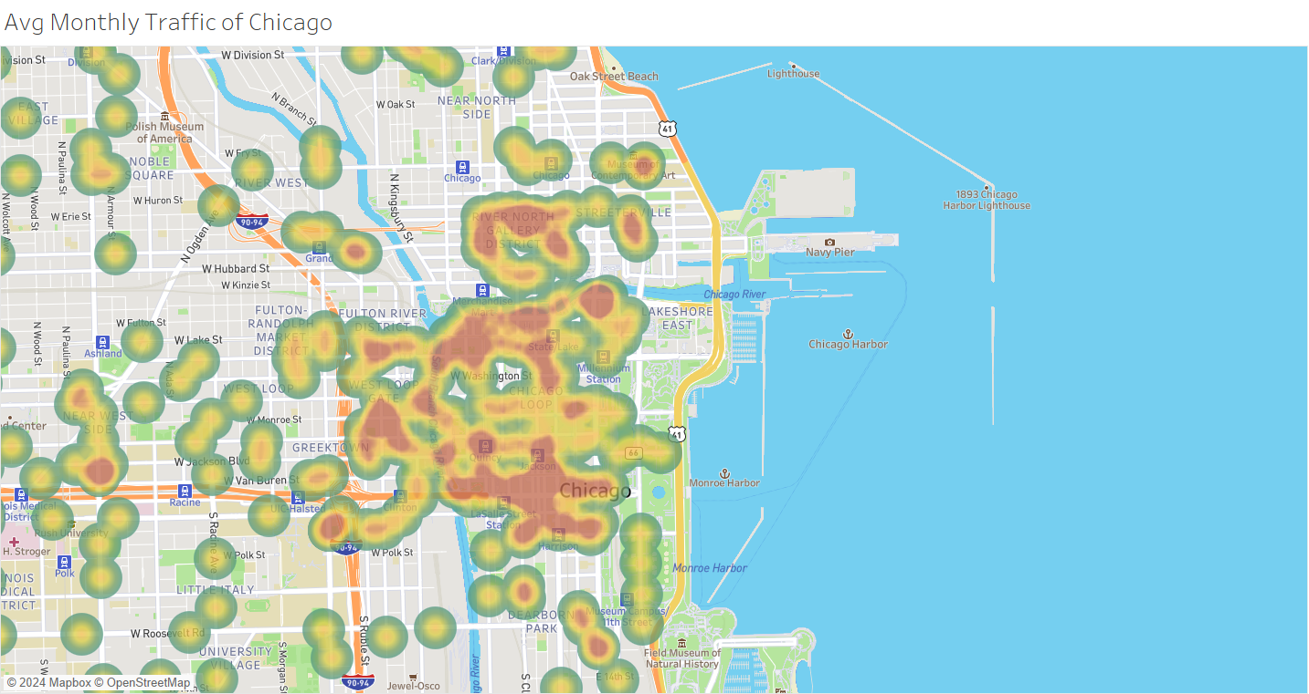

Fig. 4 Average Monthly Traffic of Chicago

# Discussion

The analysis begins with the population density map in Fig. 1, which visually represents the total population of each state in the United States. The varying sizes of circles illustrate demographic distribution, with California prominently depicted as the most populous state, while Wyoming appears smaller, indicating its lower population. Following this Fig. 2, which presents a map of average temperatures across the U.S. This map showcases substantial geographical climate variations, with a gradient from blue to orange indicating cooler climates in the northern and western states compared to the warmer southern regions. Understanding these temperature patterns is essential for various sectors, including agriculture, energy consumption, and public health, as they can influence everything from crop yields to heating and cooling needs

Next, Fig. 3 illustrates the distribution of hospitals in Chicago, color-coded by ownership type. The predominance of non-profit hospitals suggests a focus on community health, while the diversity in ownership types provides insight into healthcare accessibility disparities across regions. This information is essential for policymakers aiming to address healthcare inequities, especially in underserved areas. Finally, Fig. 4 features a heat map of average monthly traffic in Chicago, pinpointing high-traffic areas such as the downtown loop and the Magnificent Mile. This data is critical for urban planners to mitigate congestion and improve infrastructure. Together, these figures underscore the interconnectedness of population dynamics, climate, healthcare access, and urban mobility, providing a comprehensive framework for developing effective policies that promote sustainability and equity across the United States.

# Conclusions

In conclusion, our comprehensive analysis reveals the intricate relationships between population dynamics, climate variations, healthcare accessibility, and urban mobility across the United States. The population density map highlights significant demographic disparities, with states like California demonstrating substantial population concentrations. The temperature gradient map underscores the diverse climatic conditions that impact various sectors, from agriculture to energy consumption. The hospital distribution analysis in Chicago exposes healthcare ownership patterns and potential accessibility challenges, while the traffic heat map provides crucial insights into urban mobility patterns. These interconnected visualizations demonstrate the complex interplay of geographical, demographic, and infrastructural factors. By integrating data from population distribution, climate patterns, healthcare systems, and transportation networks, we can develop more nuanced and targeted policy approaches. Such holistic understanding is essential for addressing regional disparities, promoting equitable resource allocation, and creating sustainable strategies that enhance overall community well-being and resilience.

##### References

[1] “USA Statewise Population 2020”

[Online] Available: <https://www.kaggle.com/datasets/adnananam/usa-statewise-population-2020>

[2] “Climate Change: Earth Surface Temperature Data”

[Online] Available: [https://www.kaggle.com/datasets/berkeleyearth/climate-change-earth-surface-temperature-data](https://www.kaggle.com/datasets/berkeleyearth/climate-change-earth-surface-temperature-data?select=GlobalLandTemperaturesByState)

[3] “USA Hospitals”

[Online] Available: <https://www.kaggle.com/datasets/carlosaguayo/usa-hospitals>

[4] “Chicago Average Daily Traffic Counts”

[Online] Available: <https://www.kaggle.com/datasets/chicago/chicago-average-daily-traffic-counts>